Python

Lab assignment 1

**FIND LARGEST NUMBER OF THREE NUMBERS**

**Program code**

a=int(input("Enter a:"))

b=int(input("Enter b:"))

c=int(input("Enter c:"))

if b>a:

print("b is greater than a")

elif c>b:

print("c is greater than b")

elif c<a:

print("c is greater than a")

else:

print(“Invalid”)

**OUTPUT**

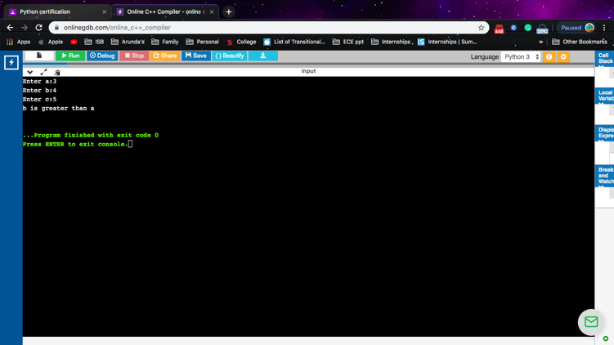

**FACTORIAL OF A NUMBER**

**Program code**

fact=1

num=int(input("Enter a positive integer to find factorial:"))

num=range(1,num+1)

for i in num:

fact=fact*i

print(fact)

**OUTPUT**



**CALCULATOR USING FUNCTIONS**

**Program Code**

def add(x,y):

return x+y

def sub(x,y):

return x-y

def mul(x,y):

return x*y

def div(x,y):

return x/y

print("Select Operation:")

print("1.Add")

print("2.Subtract")

print("3.Multiply")

print("4.Divide")

choice=int(input("Enter a choice:"))

num1=int(input("Enter first num:"))

num2=int(input("Enter second num:"))

if choice =='1':

print(num1,"+",num2,"=",add(num1,num2))

elif choice =='2':

print(num1,"-",num2,"=",sub(num1,num2))

elif choice =='3':

print(num1,"*",num2,"=",mul(num1,num2))

elif choice =='4':

print(num1,"/",num2,"=",div(num1,num2))

else:

print("Invalid input")

OUTPUT